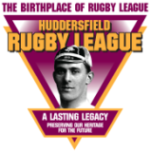 Theme 3

Timeline

Pupil Resource Sheet:

A History of Huddersfield Giants Rugby League Football Club

PART 1, 1864-1890:The Birth of the Club

The club that was to become Huddersfield Giants Rugby League Football Club was founded in 1864. Its name at that time was the Huddersfield Athletic Club.

It was founded by athletes who were dismayed that their training headquarters, the Apollo Gymnasium, which had opened in 1850, was to be converted into the Gymnasium Theatre.

On 27 January 1866 the Huddersfield Athletic Club played a ‘football’ match against the Huddersfield Rifle Corps at Rifle Field – roughly where Greenhead Park is today. This match would have appeared to us as a strange mix of association and rugby football. The first rules of association football had been written in 1863 but the first rules of rugby would not be written until 1871, and different versions of football were still played in different places.

The match was very popular and in December 1866 the Huddersfield Athletic Club started to run a football section.

There weren’t many other teams to play against so they often played amongst themselves, but in 1869 they played six matches against teams from other places.

In 1870 three of the Huddersfield players played for the Yorkshire county team and in 1872 the club started a second team.

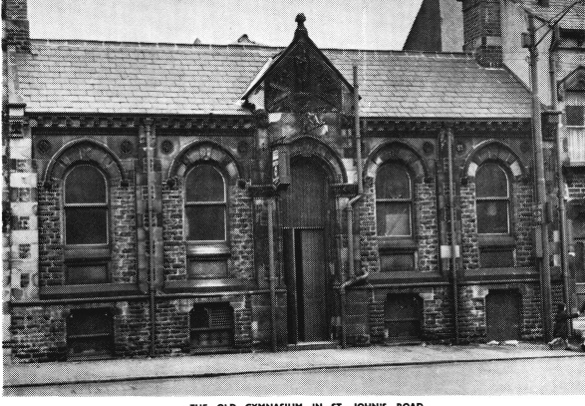
St John’s Gymnasium

In 1875 the Huddersfield Athletic Club opened a new building as its headquarters and for indoor training, the St John’s Gymnasium in St John’s Road. The last surviving piece of this building, the apex, has been restored and forms the centrepiece of the memorial garden at The John Smith’s Stadium.

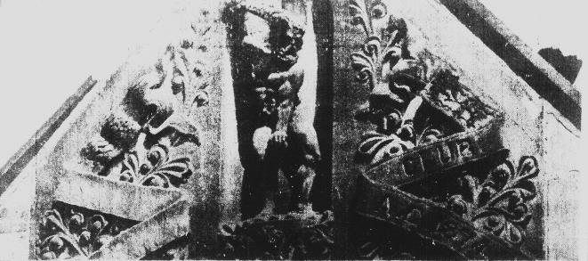
Apex of the St John’s Gymnasium (above), now restored and sited in the memorial garden at the John Smith’ Stadium (below)
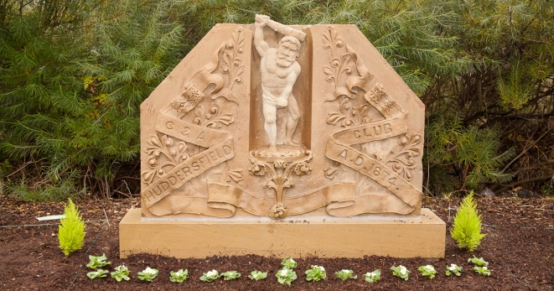

On 27 November 1875 the Huddersfield Athletic club merged with Huddersfield St John’s Cricket Club to form the Huddersfield Cricket and Athletic Club (Huddersfield C & AC). The St John’s Cricket Club had been founded in 1866, playing at Hillhouse, but had moved to Fartown in 1868.

The Football section continued to play at Rifle Field until 1878 when land next to the Fartown cricket field was developed into a rugby football ground. Huddersfield’s first match at Fartown, a victory over York, was played on 26 October 1878.

This match, like nearly all matches at this time, was a ‘club’ match. The only competition was the Yorkshire Cup which began in 1877.Five Yorkshire clubs – Bradford, Huddersfield, Hull, Leeds and York – presented the trophy to the Yorkshire RFU Committee. This trophy became known as ‘Th’ ‘owd tin pot.’

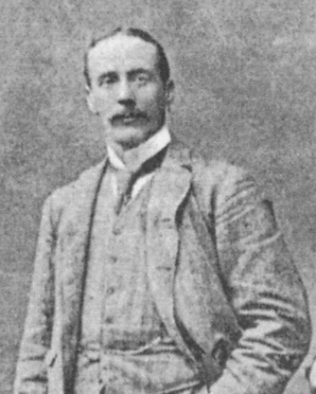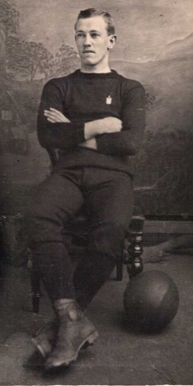
Harry Huth (left) and Harry Lodge (right)
Huddersfield captain, Harry Huth, became the club’s first international when he played for England against Scotland in the first-ever Calcutta Cup match at Edinburgh, in 1879. Other early Huddersfield internationals were Ernest Woodhead, who went on to become owner and editor of the Huddersfield Daily Examiner for many years, winger Jack Dyson and Harry Lodge. Harry Lodge went on to serve as player and committeeman for over 60 years.

Huddersfield’s first trophy, the Yorkshire Cup, was won in 1890. The team was cheered on an open-topped bus tour of the town, and a song, Hurrah for the Claret and Gold, was written in their honour.

Huddersfield’s 1890 Yorkshire Cup-winning team. Jack Dyson is standing back left.

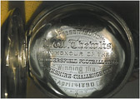
Engraved silver watch presented to
JW Thewlis as a member of Huddersfield’s 1890 Yorkshire Cup-winning team

The club made the most of this popularity by issuing 5000 shares of £1 each. The £5000 raised was spent on improving the Fartown ground in 1891.

PART 2, 1890-1895:Founder Members of Northern Union

The leading referee in the game in 1890 was the Reverend Frank Marshall, headmaster of Almondbury Grammar School. Reverend Marshall served on the Huddersfield and Yorkshire committees and strongly opposed any payments to players, either for playing, or to make up for wages they lost if they left work early to play – known as broken time pay. This seemed unfair to players in the north of England where their matches were attracting huge crowds.

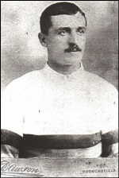
The Reverend Frank Marshall (left) and George Boak (right)

In 1893 Huddersfield was accused of attracting two Cumberland players, George Boak and Jock Forsyth, to play for them by playing them and finding work for them. They were found guilty, partly because the Reverend Marshall gave evidence against them. Huddersfield were suspended from playing their last eight matches of 1893. The Reverend Marshall, regarded as a traitor, was forced to resign from the club.

Several other northern clubs were also suspended for making payments to players. Matters came to a head in 1895. A meeting of 22 northern clubs, held at the George hotel in Huddersfield on 29 August 1895, voted to break away from the Rugby Football Union and to set up the Northern Rugby Football Union.
In 1922 Northern Union would be renamed ‘rugby league’. The 1895 meeting in Huddersfield is looked upon as the birth of rugby league. Rugby league is the only sport that knows exactly where and when it was founded.

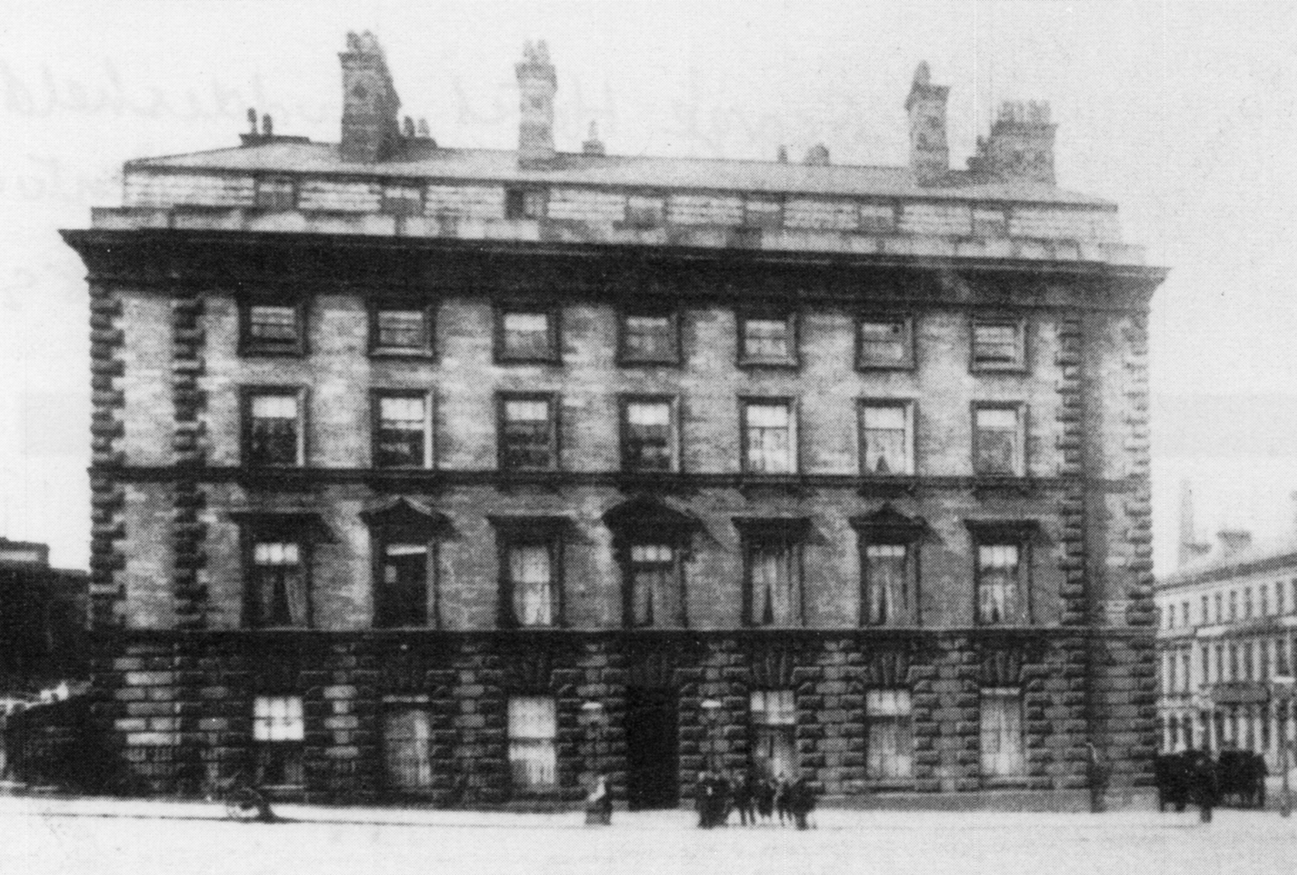
The George Hotel in 1895 and, below, the blue plaque on it today, commemorating the hotel as the birthplace of rugby league

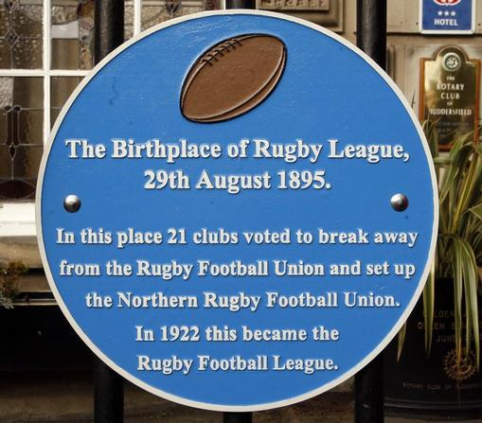

Captained by Harry Lodge, Huddersfield won their first northern union match 10-0 against Wakefield Trinity on 14 September 1895.

PART 3, 1895-1915:The Team of all Talents

The new game moved, step-by-step, away from rugby union, which banned any of its clubs from playing against northern union clubs. In 1895 broken time payment were allowed, followed in 1905 by professionalism. In 1906, to create more space on the pitch for the backs, the number of players in each team was reduced from 15 to 13.

This was perfect timing for the greatest young player the game had seen to that time, centre-threequarter Harold Wagstaff, who signed for Huddersfield from the Holmfirth club Underbank Rangers in 1906.

Harold Wagstaff remains the game’s youngest player, making his Huddersfield debut against Bramley aged 15 years 175 days.

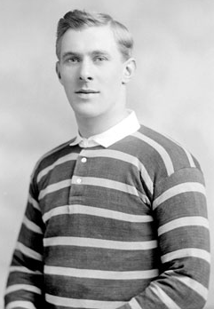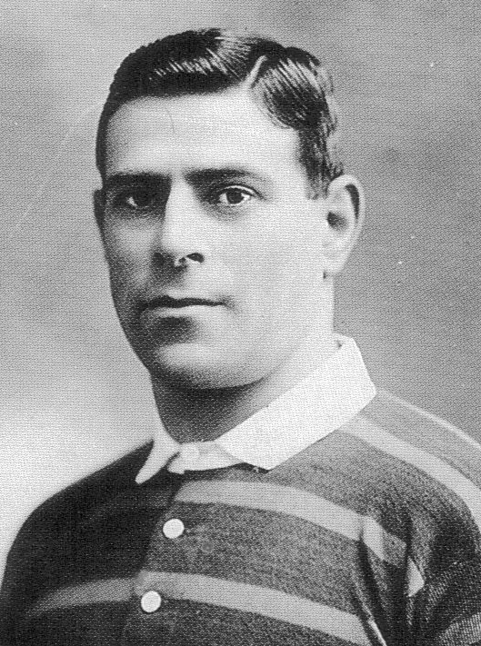
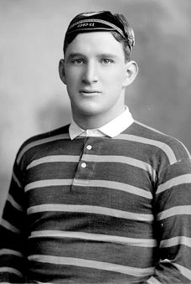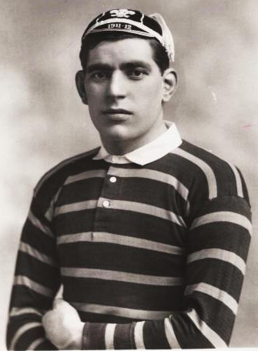
Top: Harold Wagstaff and Albert Rosenfeld
Bottom: Douglas Clark and Ben Gronow
Over the next few years Wagstaff was joined at Huddersfield by a stream of exceptional players. In 1908 Huddersfield beat the first Australian tourists 5-3 and signed two of their stars, Albert Rosenfeld and Pat Walsh.

In 1909 mighty Cumberland forward Douglas Clark signed. In 1910 he was joined the Huddersfield pack of forwards by Welsh rugby union international Ben Gronow, who earlier that year had kicked off the first ever rugby union international at Twickenham.

Extra quality was also added to the backs by Australian Tommy Gleeson and local boy, wing man Stanley Moorhouse. A former teammate of Ben Gronow from Bridgend in south Wales, quick-silver half back Johnny Rogers, signed in 1913.

This extraordinary ‘Team of all Talents’ won the Yorkshire Cup, the final of which was played in November, in 1909, 1911, 1913 and 1914. The 1911-12 season brought two more trophies, the Yorkshire League and League Championship. In 1912-13 Huddersfield won the League Championship, Challenge Cup and Yorkshire League. In 1913-14 they added the Yorkshire League to their Yorkshire Cup win. In April 1914 Albert Rosenfeld scored the last of his 80 tries in the season, still rugby league’s all-time record.

Several Huddersfield players, including Douglas Clark, Stanley Moorhouse and Fred Longstaff, toured Australia and New Zealand with the Great Britain team in 1914. The team was captained by Harold Wagstaff who inspired them to the most famous victory in the history of the game at Sydney on 4 July 1914. Injuries reduced Great Britain to just nine players at times in the second half, but they still won 14-6. It is known as the Rorke’s Drift Test Match after a famous battle in the Boer War when a vastly outnumbered British garrison resisted attacks by thousands of Zulus.

The tourists returned to a country at war, Britain having declared war on Germany on 4 August 1914, but the 1914-15 season was largely unaffected. Huddersfield swept all before them. In May 1915 they beat Leeds in the Championship Final to complete the winning of all four cups – the League Championship, Challenge Cup, Yorkshire League and Yorkshire Cup. This feat was only achieved by two other clubs – Hunslet in 1907-08 and Swinton in 1927-28.

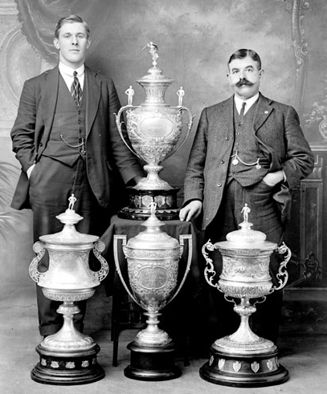
Harold Wagstaff and trainer Albert Bennett with the four cups won by Huddersfield in 1914-15

PART 4, 1915-1919:Wartime Rugby

It is hard to believe that two years after the 1914-15 Team of all Talents’ successes Huddersfield would be unable to raise a team. Such was the impact of World War I, as more and more players and supporters were called up to serve in the most dreadful conflict in history.

Payments to players were banned in the summer of 1915 until the war was over, but players continuing to play for nothing until they went off to serve in the forces.

A ‘War Emergency League’ was formed. There would be fewer matches, but most of the Northern Union teams took part. Huddersfield’s matches were often used to try to recruit volunteers for the forces. The club limped through the next two seasons until, in the summer of 1917, they announced that they had neither the players nor the money to carry on.

Some of their players played as guests to make up the numbers for other clubs, and some played in charity matches to raise money for was charities. Harold Wagstaff, Douglas Clark, Ben Gronow, Albert Rosenfeld and Stanley Moorhouse were head-hunted by Major Stanley who was in charge of Army Service Corps training at Grove Park, near Bromley in south east London. Major Stanley wanted the best rugby union team in the army. During 1916-17, their year of training, the Huddersfield players helped the Major’s team to win 25 matches out of 26.

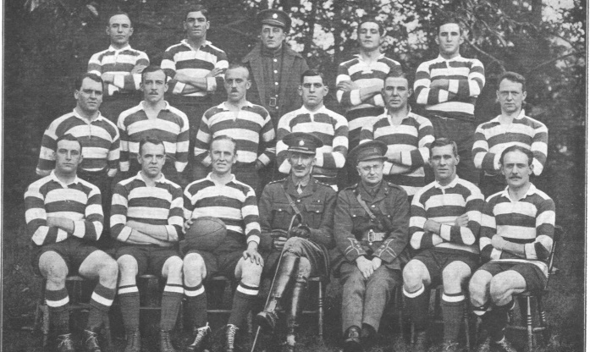
Army Service Corps team 1916-17, including Clark (back right), Gronow (third right, middle row), Wagstaff (second right, front row) and Major Stanley (centre, front row)

In 1917 they were posted to serve in various theatres of war. Douglas Clark was severely injured at the Battle of Passchendaele in 1917, but defied medical advice to play rugby again after the war, and went on to become world heavyweight wrestling champion in the 1930s. His pre-war teammate Fred Longstaff was less fortunate. In 1916 he was killed by a German flamethrower at the Battle of the Somme.

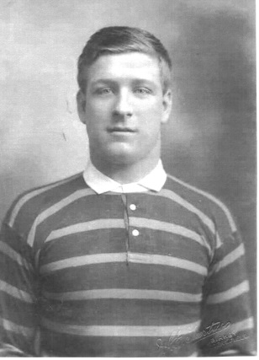
Fred Longstaff, the only member of Huddersfield’s Team of all Talents to be killed during World War I

PART 5, 1919-1945:Between the Wars and World War II

When rugby resumed in 1919 the players in Huddersfield’s Team of all Talents had lost several of their best sporting years to the war. There was, however, to be one last hurrah. The Yorkshire Cup resumed in the spring of 1919 and Huddersfield won it. This competition returned to its usual slot that autumn and Huddersfield won it again, becoming the only team to win the same trophy twice in one calendar year.

A repeat of the four cups of 1914-15 seemed likely as Huddersfield added the Yorkshire League and Challenge Cup to their trophy cabinet. For the League Championship Final against Hull in April 1920 they were handicapped by the loss of Harold Wagstaff, Johnny Rogers, Douglas Clark, Ben Gronow and Gwynn Thomas. These five players were already sailing to Australia with the Great Britain squad, again captained by Wagstaff.

Huddersfield led the final 3-0 until five minutes from time when a try by Hull’s Billy Batten deprived them of a fourth trophy.

The ageing Huddersfield team gradually broke up but the club still enjoyed the occasional triumph, winning the Yorkshire League in 1921-22, the Yorkshire Cup in 1926, and both the League Championship and the Yorkshire League in 1928-29 and 1929-30.

New heroes emerged, including captain Len Bowkett who lifted the Yorkshire Cup in 1931 and the Challenge Cup in 1933, beat in Warrington 21-17 in Huddersfield’s first match at Wembley Stadium after the annual Challenge Cup final was move there in 1929.Huddersfield returned there in 1935 but were Challenge Cup runners-up that season, losing 11-8 to Castleford.
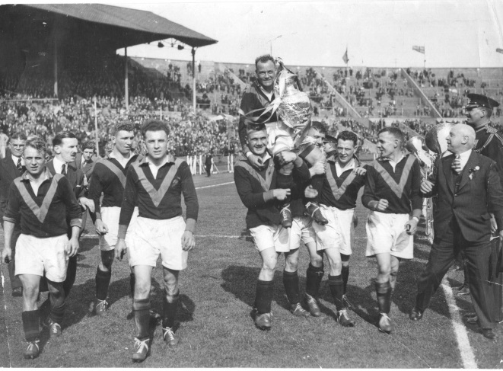
Huddersfield captain Len Bowkett and the Challenge Cup carried on a lap of honour around Wembley Stadium in 1933

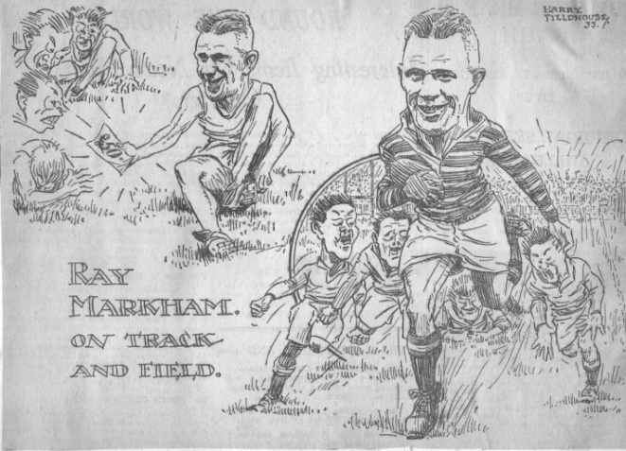
Cartoon of Australian Ray Markham, one of Huddersfield’s best players of the 1930s

Huddersfield lifted the Yorkshire Cup in 1938, the last winners of this trophy before World War II.

At the outbreak of war in 1939 the Rugby Football League was reorganised, and Huddersfield joined the other Yorkshire teams in the War Emergency League Yorkshire Section from 1939 until 1941. The Yorkshire Cup also continued.

There was conscription for unmarried men aged between 18 and 41 from the start of the war and some clubs were badly hit. As they dropped out, the remaining Yorkshire and Lancashire clubs formed one War Emergency League, in 1941-42.

One Huddersfield player died during World War II, Herbert Sherwood drowning off the coast of South America in 1942. The club held a testimonial match in his memory and to raise money for his family.

Huddersfield played more wartime matches than any other club, and ended the war as Challenge Cup winners in 1945, beating Bradford Northern 13-9 on aggregate over two matches, 7-4 at Huddersfield and 6-5 at Bradford.

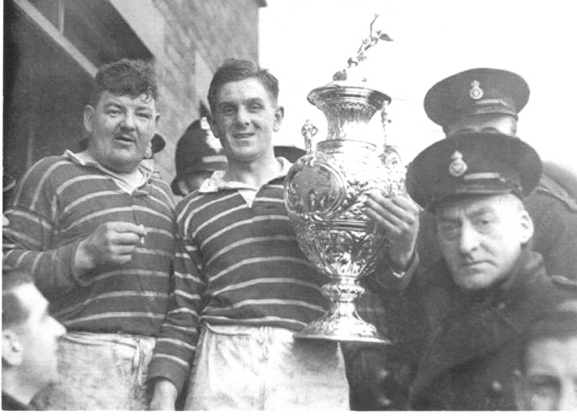
Alex Fiddes, who played 467 matches for Huddersfield between 1933 and 1947, lifts the Challenge Cup in 1945.

PART 6, 1945-1962:Another Golden Era

Huddersfield made some inspired signings after World War II. In 1947 the great Australian trio Lionel Cooper, Johnny Hunter and Pat Devery all joined the club, along with Scottish rugby union international forward, Dave Valentine. They were joined in 1949 by full back Frank Dyson and in 1951 by rugged forward Peter Ramsden.

In 1948-49 Huddersfield won the Yorkshire League and League Championship, beating Warrington 13-12 in the League Championship Final at Manchester City’s ground, Maine Road, before a new rugby league world record crowd of crowd of 75,194.

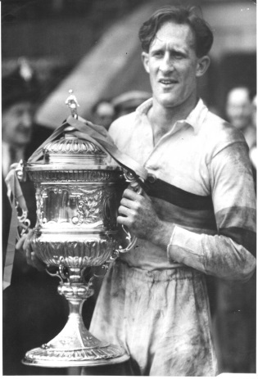
Left: Pat Devery lifts the 1949 Championship Trophy.
Right: Johnny Hunter in full flight

Huddersfield retained the Yorkshire League in 1949-50 and were runners-up in the League Championship, losing the final 20-2 to Wigan.

The Yorkshire Cup was won in 1950, 1951 and 1952, and the Yorkshire League in 1951-52. Highlight of the season was Lionel Cooper’s ten tries against Keighley, still a club record for tries on one match.

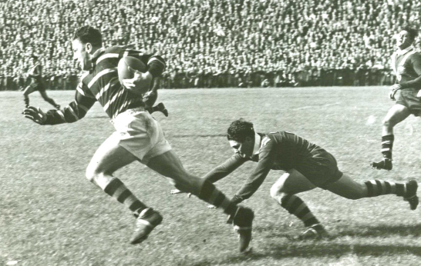
Lionel Cooper on another powerful run

Huddersfield returned to Wembley in 1953 to play St Helens in the Challenge Cup Final. It was Peter Ramsden’s day. He scored two tries on his 19th birthday to become the youngest winner of the Lance Todd (man-of-the-match) Trophy as Huddersfield won 15-10. It was the second final to be televised, the first being the 1952 final.

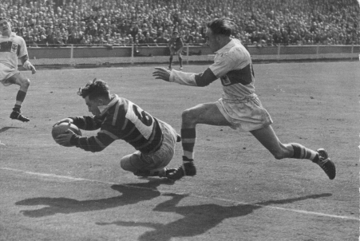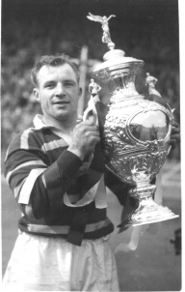
Left: Peter Ramsden grounds the first of his 1953 Wembley tries.
Right: Captain Russ Pepperell lifts the 1953 Challenge Cup Trophy.

1954 saw the first-ever Rugby League World Cup. Huddersfield and Great Britain captain, Dave Valentine, was the first player to lift the trophy. The Great Britain team included great Huddersfield left wingman Mick Sullivan, who went on to play a record 46 times for Great Britain. In Sullivan and New Zealand international sprinter Peter Henderson, Huddersfield had the best wing men in the game.

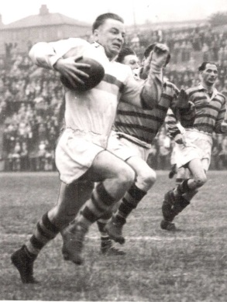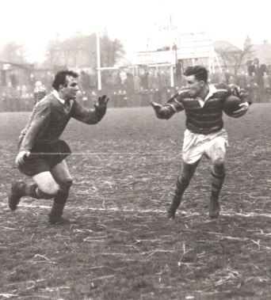
Left: Peter Henderson
Right: Mick Sullivan

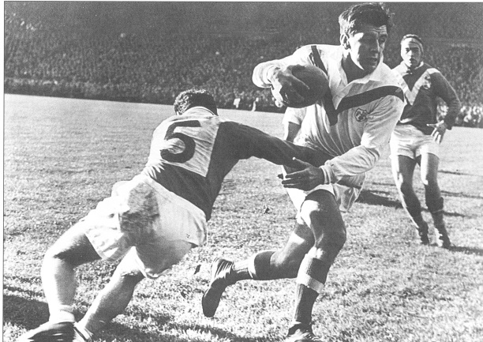
Dave Valentine bursts through another tackle

Dave Valentine retired shortly after Huddersfield beat York 15-8 in the final of the Yorkshire Cup in November 1957.

Led by the inspirational Tommy Smales, a brilliant tactician who also captained Great Britain, and record goal-kicker Frank Dyson, Huddersfield enjoyed a superb season in 1961-62, losing 12-6 to Wakefield Trinity in the Challenge Cup at Wembley, but beating them 14-5 a week later in the Championship Final at Odsal, Bradford.

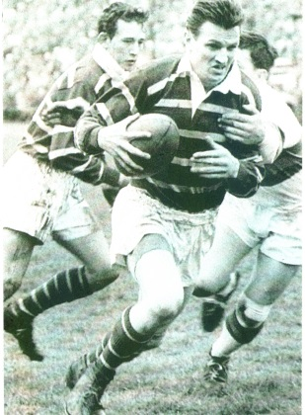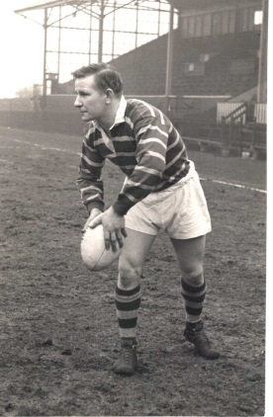
Tommy Smales and Frank Dyson

.

PART 7, 1963-1996:Dark Days

From the early 1960s Huddersfield and its rugby league club began three difficult decades. As the town’s factory industries declined, so did the team that many of these workers supported. Lack of funds limited the quality of players the club could afford. Although floodlights were installed at Fartown in 1967, the ground gradually fell into disrepair.

Huddersfield was usually towards the bottom of the League Championship and when the game experimented with different division, they were usually in the lower ones, although they did win the Division 2 Championship in 1974-75.

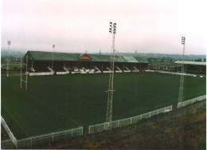
Fartown, Huddersfield’s home for 114 years

Great Britain international Ken Senior was the club’s outstanding player through the 1960s and 1970s, playing 474 matches for the club, second only to Douglas Clark.
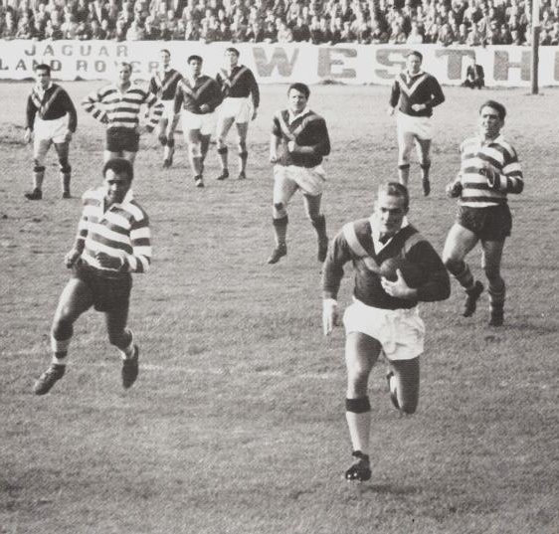
Ken Senior leaves defenders in his wake to score another try.

By the early 1980s crowds were down to just a few hundred. In 1984, attempts to boost interest by renaming the club ‘Huddersfield Barracudas’ and the Fartown Ground ‘Arena 84’ proved unpopular and both were abandoned in 1988.

The tireless and admirable efforts of a small band of volunteers led by Keith Burhouse and his family kept the club afloat, but without investment they were largely restricted to patching up the increasingly dilapidated ground.

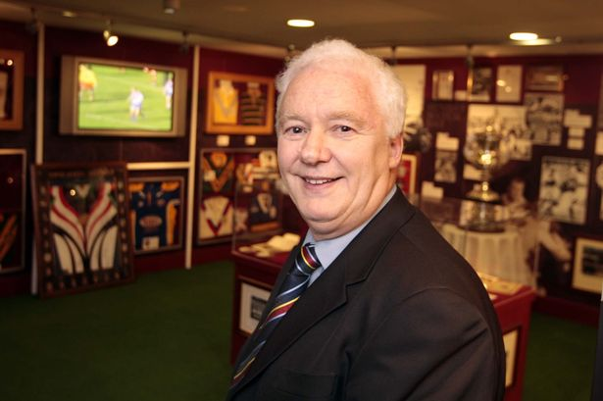
Keith Burhouse
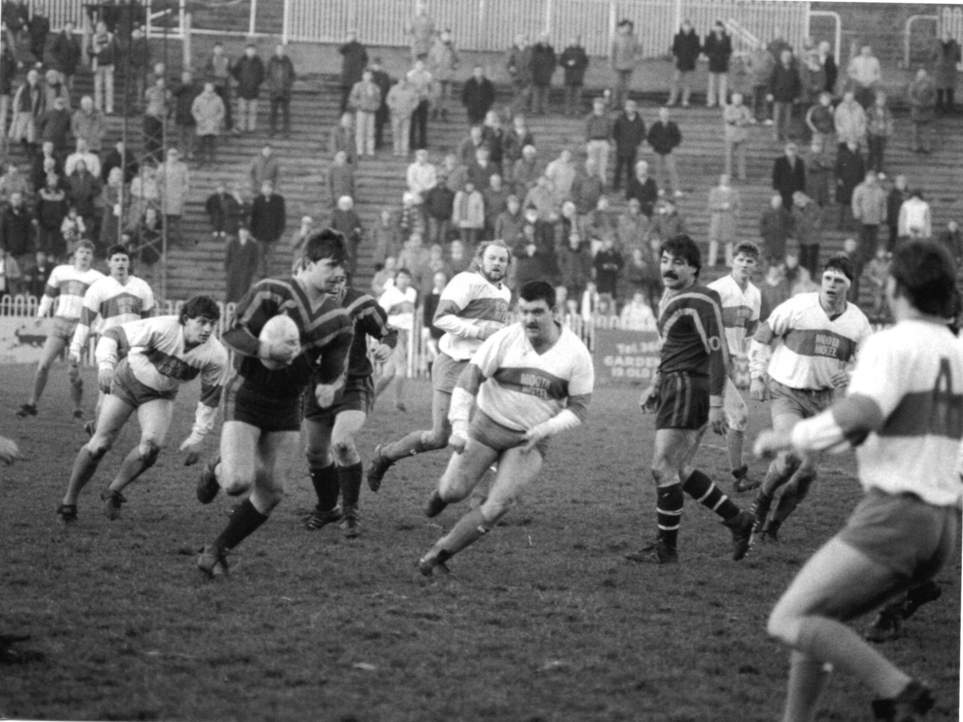
Paul Dixon carries the ball through the Workington defence for Huddersfield Barracudas in 1986.

In the wake of the football ground disasters of the 1980s at Bradford City (1985) and Hillsborough (1989), stricter ground safety rules were introduced. Unable to afford them, Huddersfield Rugby League FC was forced to leave Fartown in 1992 and began to share Huddersfield Town’s ground at Leeds Road.

In 1991-92 the club were champions of Division 3, but could not pay its debts and went into administration.

Bizarrely, in 1993, they were invited to play in the first European Club Championship along with five other teams. When four of these withdrew, Huddersfield played XIII Catalan in Barcelona for the title of European Champions, which they won.

In 1994 Huddersfield beat Blackpool Gladiators 142-4 to set new world records for points in a game and margin of victory. Greg Austin set new records for a centre of 9 tries in a match and 52 tries in the season.

The club moved to the new McAlpine (now John Smith’s) Stadium in 1994, which they continue to share with Huddersfield Town.

PART 8, 1996-2015:Summer Rugby and Super League
1996 brought an upturn in fortunes for the club and for the game. Professional rugby league moved to a summer season and, boosted by money from satellite television, Super League was formed. Clubs adopted American-style names and Huddersfield was renamed Huddersfield Giants.

Ken Davy became Chairman and brought security to the club’s finances which helped them to be more successful on the field.

In 1997 they beat Hull 18-0 in the Divisional Championship Final at Old Trafford and won promotion to Super League. The club’s first season in Super League was 1998.

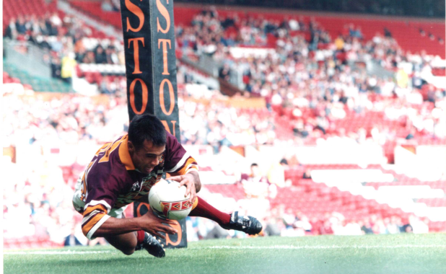Ali Davies scores in the 1997 Divisional Championship final at Old Trafford

In 1999 Huddersfield merged with Sheffield Eagles, playing as Huddersfield-Sheffield Giants. It was unpopular with fans of both clubs and abandoned after one season.

Huddersfield Giants was relegated from Super League in 2001. Unbeaten in 2002, they were promoted back to Super League as National League champions. Huddersfield scored a record 1156 points in the season.

This time Huddersfield established themselves among the best clubs in the game. In 2006 they reached the Challenge Cup Final, losing 42-12 to St Helens in the Wembley final.
In 2009 the club finished third in Super League. Brett Hodgson became the first Huddersfield player to be named ‘Man of Steel’, and he inspired the club to reach the Challenge Cup Final, where they lost 25-16 to Warrington.

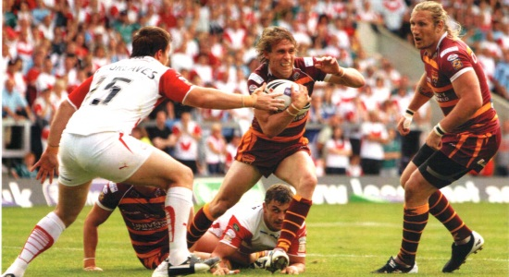
Brett Hodgson, watched by Eorl Crabtree, takes on the St Helens defence in the 2009 Challenge Cup Semi-Final

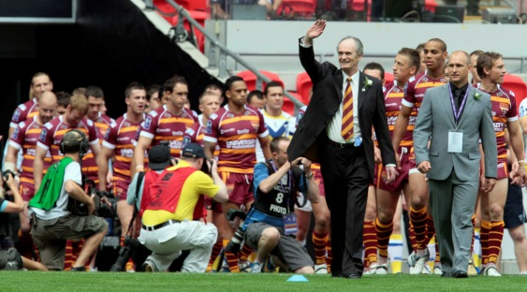
Led by Ken Davy and coach Nathan Brown, Huddersfield out at Wembley in 2009.

In 2013, captain Danny Brough was named ‘Man of Steel’, set a new record for goals kicked in a season, and led Huddersfield to the League Leader’s Shield.

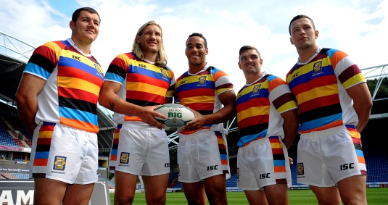
Brett Ferres, Eorl Crabtree, Leroy Cudjoe, Danny Brough and Shaun Lunt were in the 2013 Super League ‘Team of the Season’.

Huddersfield continued as one of the leading clubs in 2014, finishing 3rd in Super League.

